ITEC 570 SPRING 2024

SQL Lab4A

Database Sequences and Triggers Ch 8

Ahmed Altouqi

For each document submitted on-line, please include your name, username, date, ITEC 570-001, reference lab number and title(if appropriate). You will turn in 4 screenshots. One after each problem.

SEQUENCES. A sequence is a database object that generates and produces integer values in sequential order. Useful when you need to create a unique number to act as a primary key.

Here is the basic syntax of the CREATE SEQUENCE statement:

CREATE SEQUENCE schema_name.sequence_name
[INCREMENT BY interval]
[START WITH first_number]
[MAXVALUE max_value | NOMAXVALUE]
[MINVALUE min_value | NOMINVALUE]
[CYCLE | NOCYCLE]
[CACHE cache_size | NOCACHE]
[ORDER | NOORDER];

- Basic Oracle Sequence example
- The following statement creates an ascending sequence called id_seq, starting from 10 and incrementing by 10, with a minimum value of 10 and a maximum value of 100. Because of the CYCLE option, the sequence returns 10 once it reaches 100.

CREATE SEQUENCE id_seq
INCREMENT BY 10
START WITH 10
MINVALUE 10
MAXVALUE 100
CYCLE
CACHE 2;

- To get the next value of the sequence, you use the NEXTVAL pseudo-column:

SELECT id_seq.NEXTVAL FROM dual;

- To get the current value of the sequence, you use the CURRVAL pseudo-column:

SELECT id_seq.CURRVAL FROM dual;

SELECT id_seq.NEXTVAL FROM dual;

Take a SCREENSHOT.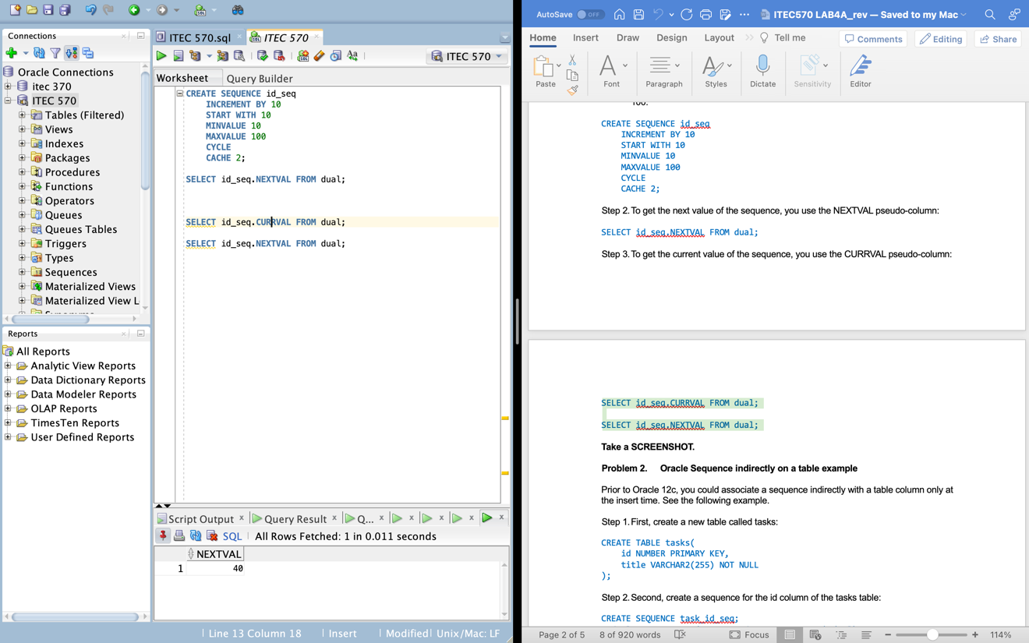

- Oracle Sequence indirectly on a table example

Prior to Oracle 12c, you could associate a sequence indirectly with a table column only at the insert time. See the following example.

- First, create a new table called tasks:

CREATE TABLE tasks(
id NUMBER PRIMARY KEY,
title VARCHAR2(255) NOT NULL
);

- Second, create a sequence for the id column of the tasks table:

CREATE SEQUENCE task_id_seq;
Code language: SQL (Structured Query Language) (sql)

- Third, insert data into the tasks table:

INSERT INTO tasks(id, title)
VALUES(task_id_seq.NEXTVAL, 'Create Sequence in Oracle');

INSERT INTO tasks(id, title)
VALUES(task_id_seq.NEXTVAL, 'Examine Sequence Values');

INSERT INTO tasks(id, title)
VALUES(task_id_seq.NEXTVAL, 'Examine More Sequence Values');

- Finally, query data from the tasks table:

SELECT USER FROM DUAL;
SELECT id, title FROM tasks;

Take a SCREENSHOT.
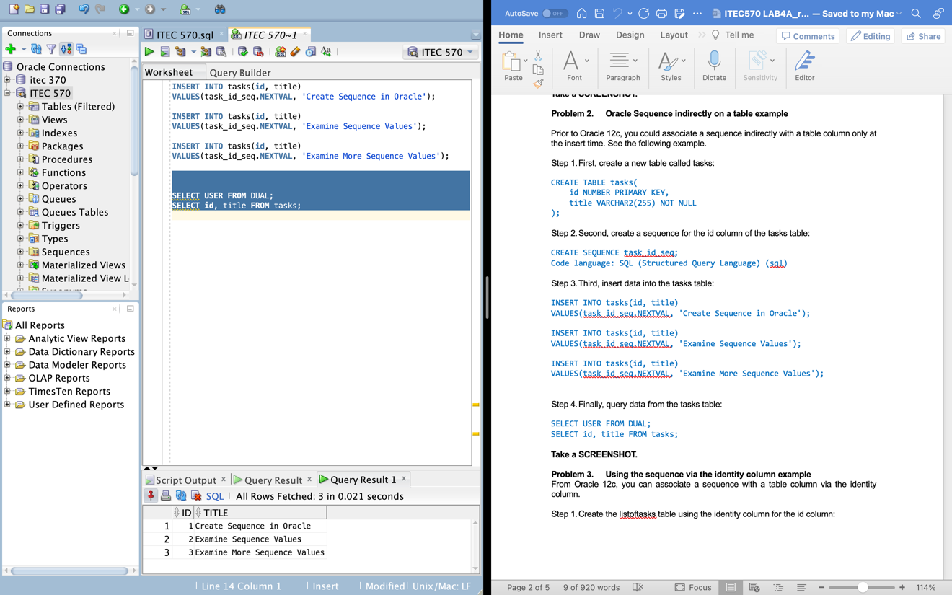

- Using the sequence via the identity column example
From Oracle 12c, you can associate a sequence with a table column via the identity column.

- Create the listoftasks table using the identity column for the id column:

CREATE TABLE listoftasks(
id NUMBER GENERATED ALWAYS AS IDENTITY PRIMARY KEY,
title VARCHAR2(255) NOT NULL
);

Behind the scenes, Oracle creates a sequence that is associated with the id column of the tasks table.

Because Oracle generated the sequence automatically for the id column, in your Oracle instance, the name of the sequence may be different.

Oracle Create Sequence - identity column
Oracle uses the sys.idnseq$ to store the link between the table and the sequence.
REVISION

SELECT
Sequence_owner,
sequence_name
FROM all_sequences
WHERE
Sequence_owner = ‘Your UserId Here’;

- insert some rows into the tasks table:

INSERT INTO listoftasks(title)
VALUES('Learn Oracle identity column in 12c');

INSERT INTO listoftasks(title)
VALUES('Verify contents of the tasks table');

INSERT INTO listoftasks(title)
VALUES('Verify contents of the tasks table');

INSERT INTO listoftasks(title)
VALUES('Verify contents of the tasks table');

- Finally, query data from the tasks table:

SELECT user FROM dual;
SELECT id, title FROM listoftasks;

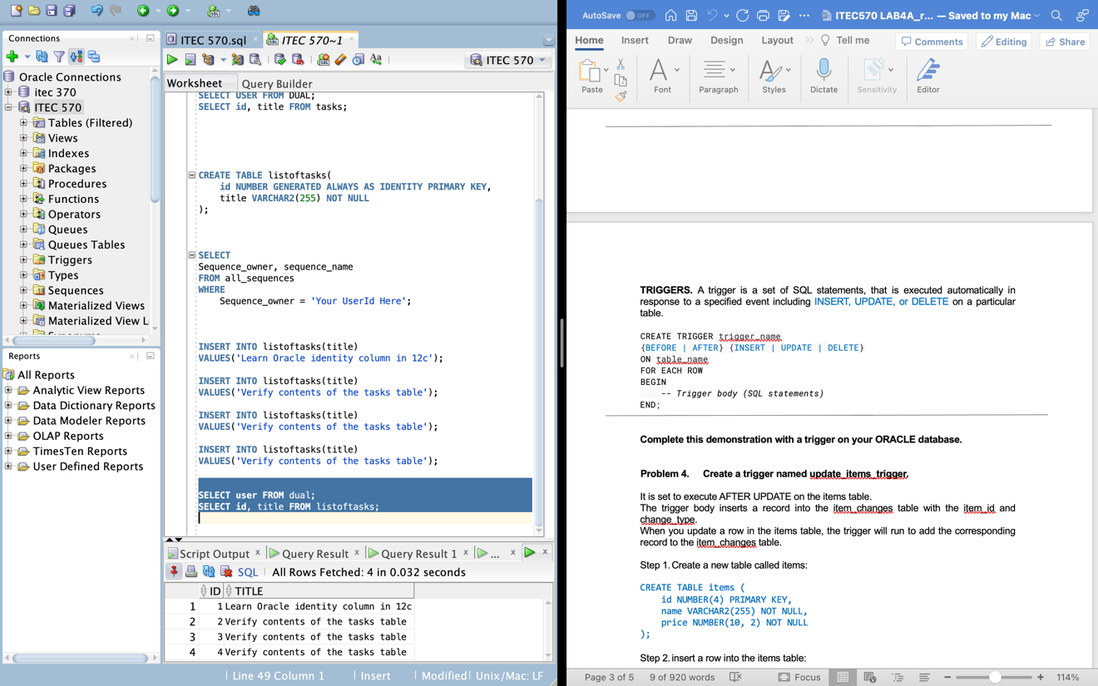
Take a SCREENSHOT.

TRIGGERS. A trigger is a set of SQL statements, that is executed automatically in response to a specified event including INSERT, UPDATE, or DELETE on a particular table.

CREATE TRIGGER trigger_name
{BEFORE | AFTER} {INSERT | UPDATE | DELETE}
ON table_name
FOR EACH ROW
BEGIN
-- Trigger body (SQL statements)
END;

Complete this demonstration with a trigger on your ORACLE database.

- Create a trigger named update_items_trigger.

It is set to execute AFTER UPDATE on the items table.
The trigger body inserts a record into the item_changes table with the item_id and change_type.
When you update a row in the items table, the trigger will run to add the corresponding record to the item_changes table.

- Create a new table called items:

CREATE TABLE items (
id NUMBER(4) PRIMARY KEY,
name VARCHAR2(255) NOT NULL,
price NUMBER(10, 2) NOT NULL
);

- insert a row into the items table:

INSERT ALL
INTO items VALUES (1, 'chair', 50.00)
INTO items VALUES (2, 'book', 24.95)
INTO items VALUES (3, 'plate', 5.54)
select * from dual;

OR use separate insert statements.

- Third, create the item_changes table to store the changes made to the data in the items table:REVISION

CREATE TABLE item_changes (
change_id NUMBER GENERATED ALWAYS AS IDENTITY PRIMARY KEY,
item_id NUMBER(4),
change_type VARCHAR2(10),
change_timestamp DATE DEFAULT SYSDATE
);

- Create a Foreign Key on item_id referring to the item table.
REVISION
ALTER TABLE item_changes
ADD CONSTRAINT item_id_FK FOREIGN KEY (item_id) REFERENCES ITEMS(id);

- create a trigger called update_items_trigger associated with the items table:
// start code
REVISION

CREATE OR REPLACE TRIGGER update_items_trigger
AFTER UPDATE
ON items
FOR EACH ROW
BEGIN
INSERT INTO item_changes (item_id, change_type)
VALUES (:NEW.id, 'UPDATE');
END;

//end code

*** Open a new SQL sheet to run these ***
The user changing the database objects should not be the same entering data.

- Update a row in the items table:

UPDATE items
SET price = 60.00
WHERE id = 1;

- Finally, retrieve data from the item_changes table to see the logged changes:

SELECT USER FROM DUAL;
SELECT * FROM items;
SELECT * FROM item_changes;

Take a SCREENSHOT.

Question. Can you think of a real world scenario when you would use a trigger like this one?

